**Windows AD integration with Angular FrontEnd and .NET Core Api**

* This document describes the technological limitations due to which we cannot implement “Windows AD integration with Angular Frontend with .NET Core API”
* There are 3 major technology stack of the system that are involved into this research
  1. Windows AD authentication
  2. Angular Frontend
  3. .Net Core Api Backend
* We are trying to implement/build an intranet system with below functionality using above tech requirements.
  1. When the angular frontend loads, windows authentication prompt must be displayed asking the users window credentials.
  2. System user must enter his window credentials in order to login into the system.
  3. Once user enters the credentials, the same credentials must be authenticated from backend api based on which the angular home page gets loaded.
* The limitation that we are facing in implementing the above requirement is mentioned below:
  1. In Angular, once a user enters credentials the home page gets loaded directly before waiting for auth approval from backend api, as a counter we tried below things, which did not work.
     1. We tried various stop/delay approaches in Angular to load and display home page until the window AD credentials entered by user is send to backend api and gets authenticated by it and success or failure response comes back to angular frontend callback function. Example: tried using Auth Interceptor,Auth Guard, Route manipulation etc.
     2. Other possibility we tried in angular is to get the credentials entered by user through angular window libraries before loading angular home page, but as angular is a JavaScript framework (whose processing domain is browser only and not the windows AD which is auth mechanism applied on our frontend from deployment server), The security mechanism does not allow us to fetch the creds from windows AD prompt, as that is considered a serious security threat.
* Below are the possible ways, we can achieve the auth functionality with given technologies are as follows:
  1. Create a login page in angular frontend instead Windows AD prompt.
* Following is the demo of how to create a login page in the angular frontend instead Windows AD prompt

1. Created a login page with two fields username and password along with one submit button using Bootstrap in the angular frontend.

2. Created API in .net core which returns current window user login name

3. Tested API in Swagger which successfully return the current username

4. Try to validate the user by calling API from the .net core to the angular frontend.

The main target to perform this demo is will send a username and password from the angular side and validate the username in the .net core side (as getting the current windows user login). Then Will compare the username got from frontend and the username get from the API. if the username is matched login will be successful else throw an error as an invalid user.

Following are the screenshots of this demo:

* + When User is incorrect: The response in API will be **Bad Request(400)** and will get message **Invalid User.**

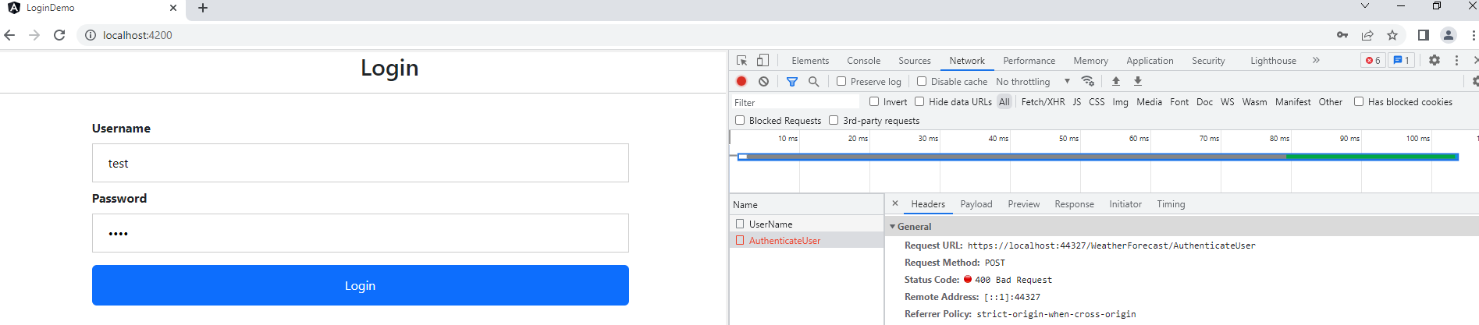

* + When User is correct: The response in API will be **ok(200)** and will get message **login Successfully Done.**